Name: Parshwa Shah
UID:-2019230071

CEL 51, DCCN, Monsoon 2020
Lab 2: Basic Network Utilities

This lab introduces some basic network monitoring/analysis tools. There are a few exercises along the way. You should write up answers to the ping and traceroute exercises and turn them in next lab. (You should try out each tool, whether it is needed for an exercise or not!).

Prerequisite: Basic understanding of command line utilities of Linux Operating system.

Some Basic command line Networking utilities

Start with a few of the most basic command line tools. These commands are available on Unix, including Linux (and the first two, at least, are also for Windows). Some parameters or options might differ on different operating systems. Remember that you can use man <command> to get information about a command and its options.

ping — The command ping <host> sends a series of packets and expects to receieve a response to each packet. When a return packet is received, ping reports the round trip time (the time between sending the packet and receiving the response). Some routers and firewalls block ping requests, so you might get no reponse at all. Ping can be used to check whether a computer is up and running, to measure network delay time, and to check for dropped packets indicating network congestion. Note that <host> can be either a domain name or an IP address. By default, ping will send a packet every second indefinitely; stop it with Control-C

Network latency, specifically round trip time (RTT), can be measured using ping, which sends ICMP packets. The syntax for the command in Linux or Mac OS is:
ping [-c <count>] [-s <packetsize>] <hostname>

The syntax in Windows is:

ping [-n <count>] [-l <packetsize>] <hostname>

The default number of ICMP packets to send is either infinite (in Linux and Mac OS) or 4 (in Windows). The default packet size is either 64 bytes (in Linux) or 32 bytes (in Windows). You can specify either a hostname (e.g., spit.ac.in) or an IP address.

To save the output from ping to a file, include a greater than symbol and a file name at the end of the command. For example:
ping -c 10 google.com > ping_c10_s64_google.log

Experiments with Ping
- Ping the any hosts 10 times (i.e., packet count is 10) with a packet size of 64 bytes, 100 bytes, 500 bytes, 1000 bytes, 1400 bytes
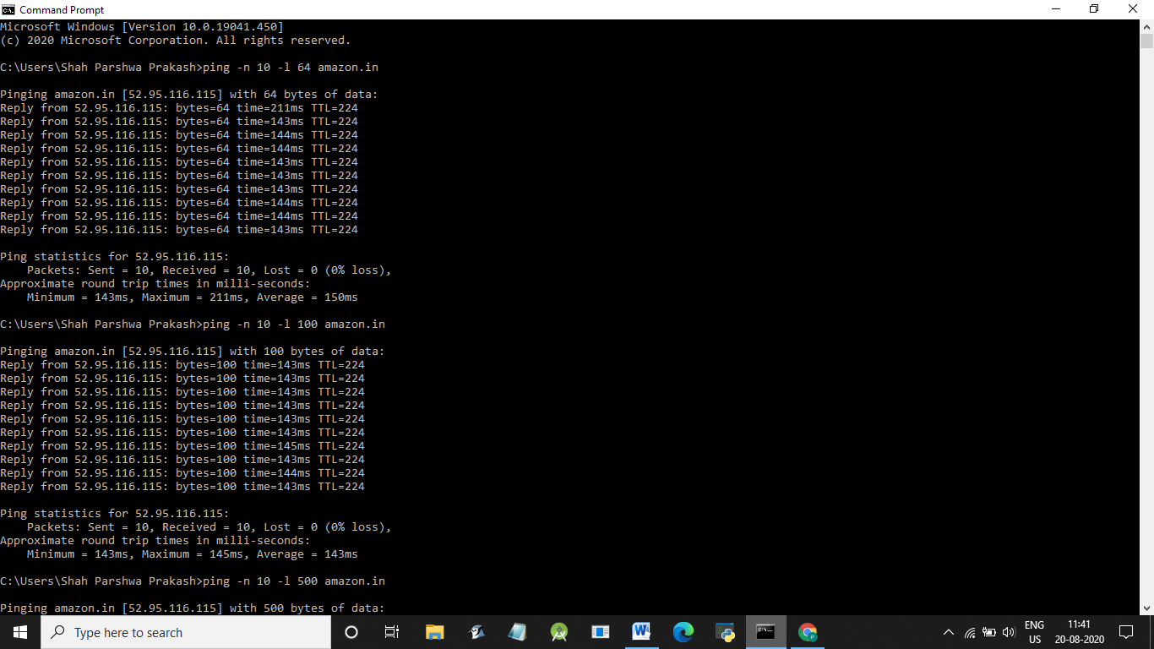

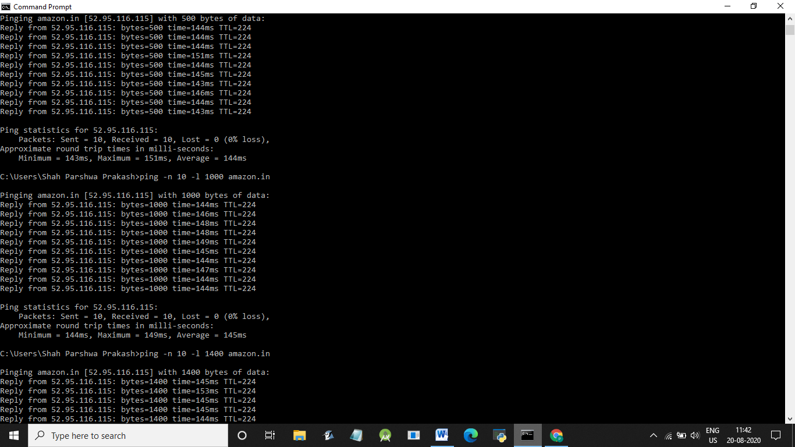

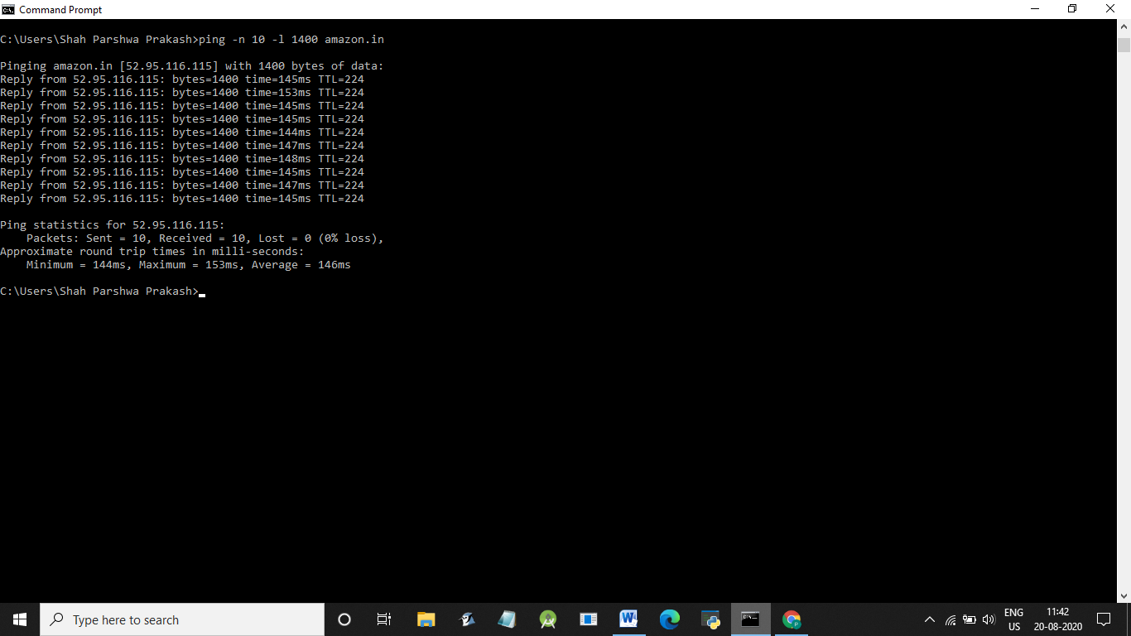
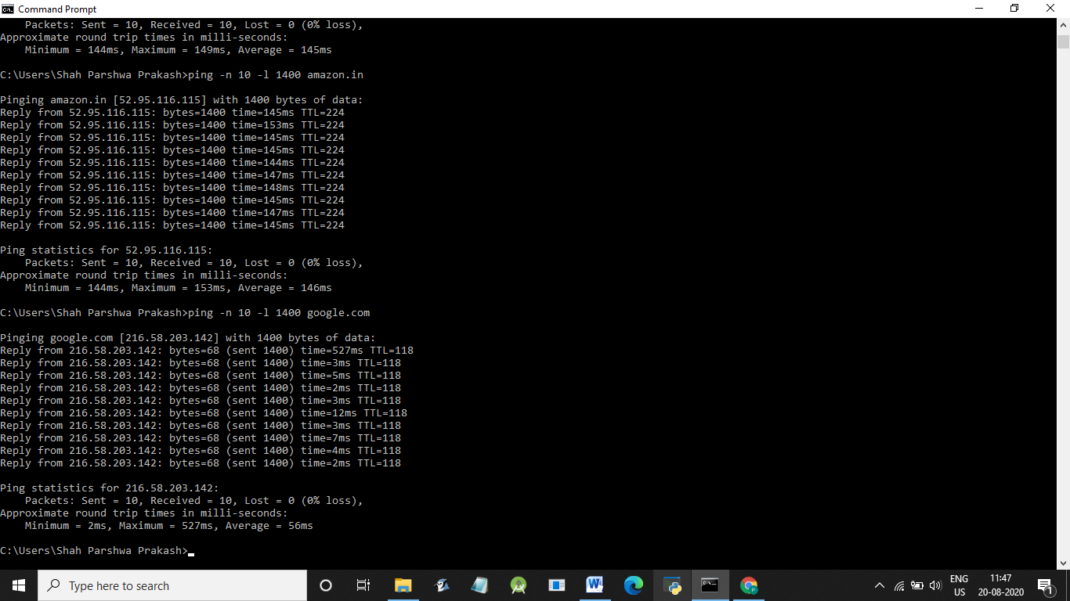
Questions About Latency
Now look at the results you gathered and answer the following questions about latency. Store your answers in a file named ping.txt.
- Does the average RTT vary between different hosts? What aspects of latency (transmit, propagation, and queueing delay) might impact this and why?
Yes, RTT varies between different hosts.The factors which affect this are:
- Distance – The length a signal has to travel correlates with the time taken for a request to reach a server and a response to reach a browser.
- Transmission medium – The medium used to route a signal (e.g., copper wire, fiber optic cables) can impact how quickly a request is received by a server and routed back to a user.
- Number of network hops – Intermediate routers or servers take time to process a signal, increasing RTT. The more hops a signal has to travel through, the higher the RTT.
- Does the average RTT vary with different packet sizes? What aspects of latency (transmit, propagation, and queueing delay) might impact this and why?
Yes,RTT varies with different packet sizes.
Transmission medium as well as propagation distance affect this because more the size of packets,more time it takes to transmit.
Exercise 1: Experiment with ping to find the round trip times to a variety of destinations. Write up any interesting observations, including in particular how the round trip time compares to the physical distance. Here are few places from who to get replies: www.uw.edu, www.cornell.edu, berkeley.edu, www.uchicago.edu, www.ox.ac.uk (England), www.u-tokyo.ac.jp (Japan).
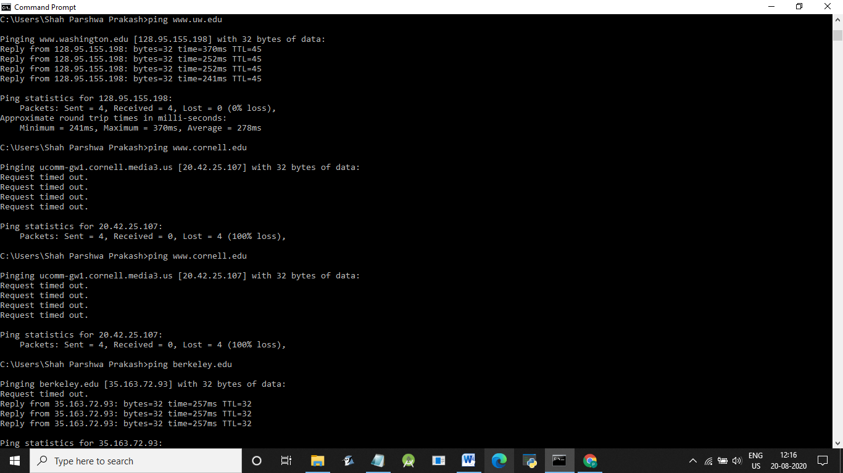

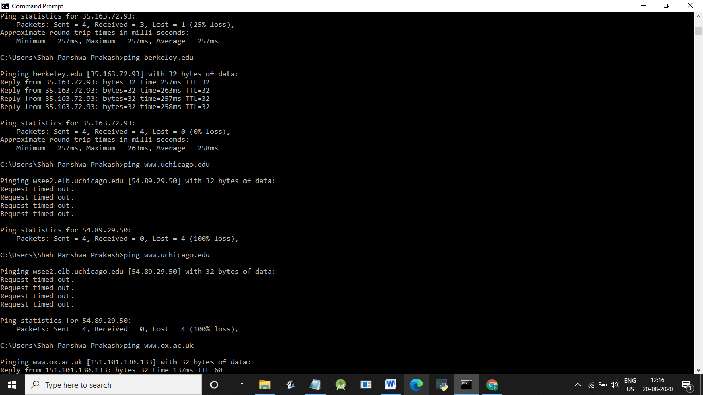

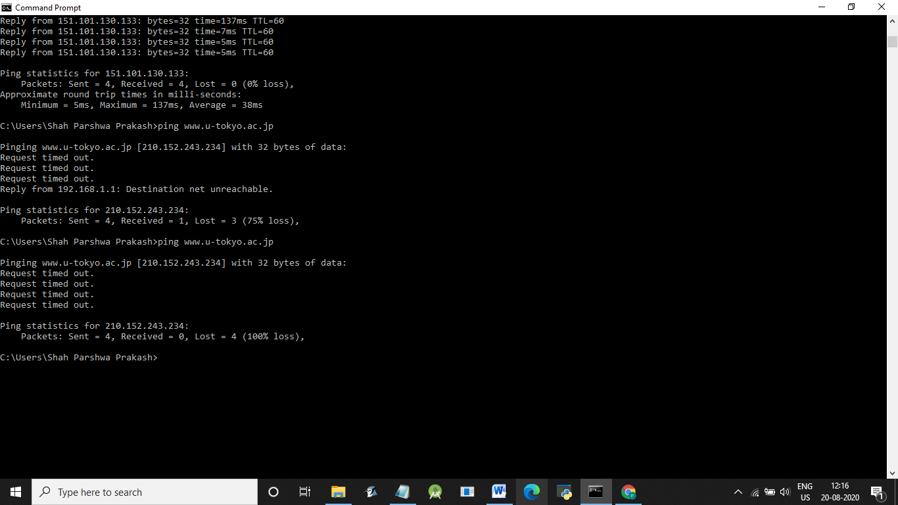
The distance, a signal has to travel correlates with the time taken for a request to reach a server and a response to reach a browser.One interesting observation is while making ping to u-tokyo.ac.jp.I got output as ‘Destination net unreachable’ which means packet has stopped somewhere between the network.

nslookup — The command nslookup <host> will do a DNS query to find and report the IP address (or addresses) for a domain name or the domain name corresponding to an IP address. To do this, it contacts a "DNS server." Default DNS servers are part of a computer's network configuration. (For a static IP address in Linux, they are configured in the file /etc/network/interfaces that you encountered in the last lab.) You can specify a different DNS server to be used by nslokup by adding the server name or IP address to the command: nslookup <host> <server>

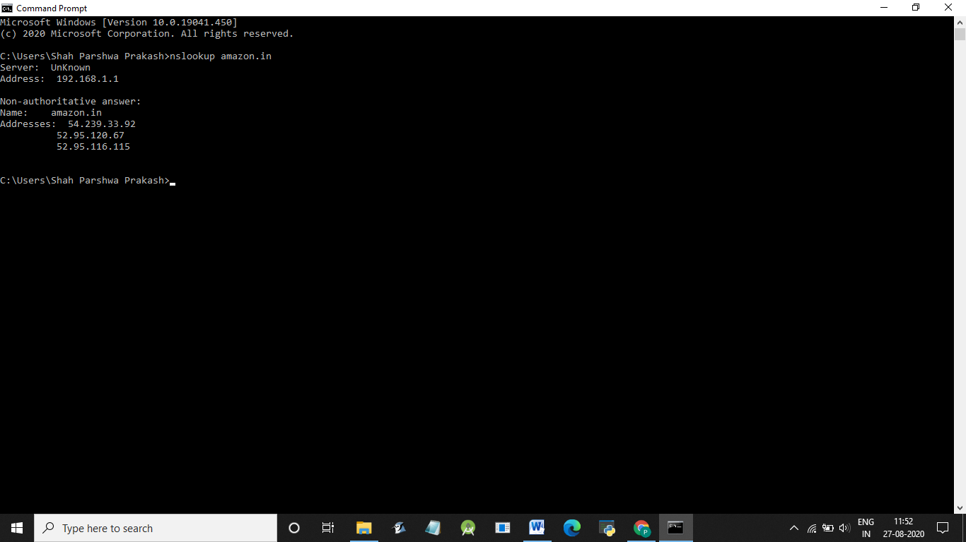

ifconfig — You used ifconfig in the previous lab. When used with no parameters, ifconfig reports some information about the computer's network interfaces. This usually includes lo which stands for localhost; it can be used for communication between programs running on the same computer. Linux often has an interface named eth0, which is the first ethernet card. The information is different on Mac OS and Linux, but includes the IP or "inet" address and ethernet or "hardware" address for an ethernet card. On Linux, you get the number of packets received (RX) and sent (TX), as well as the number of bytes transmitted and received. (A better place to monitor network bytes on our Linux computers is in the GUI program System Monitor, if it is installed!!!.)

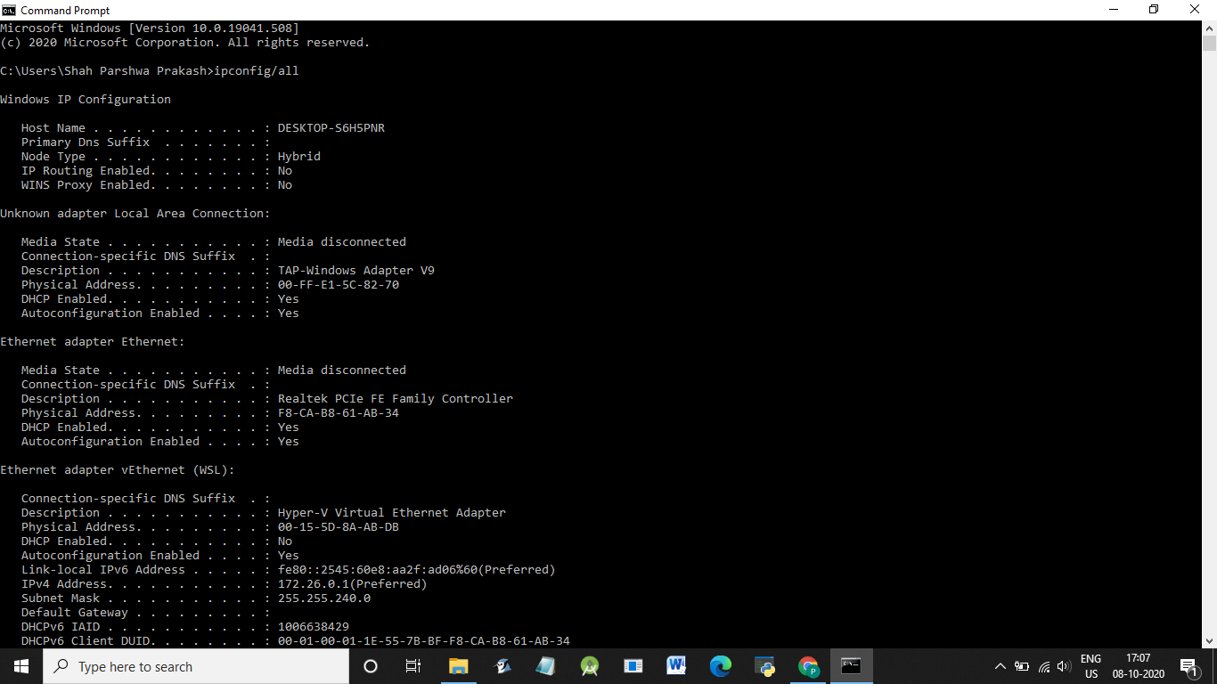

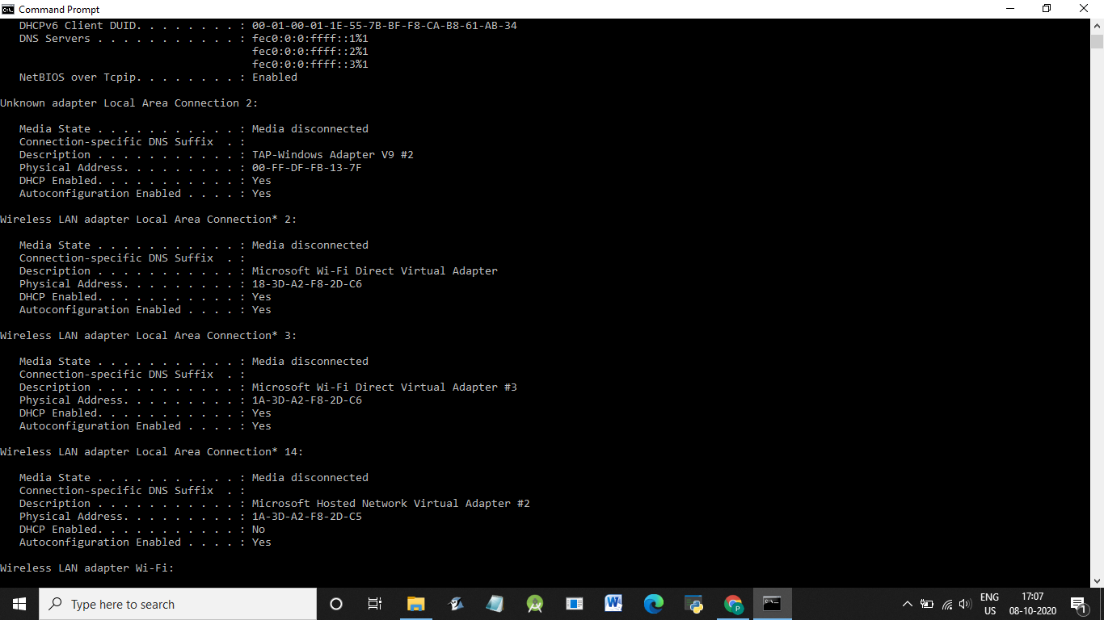

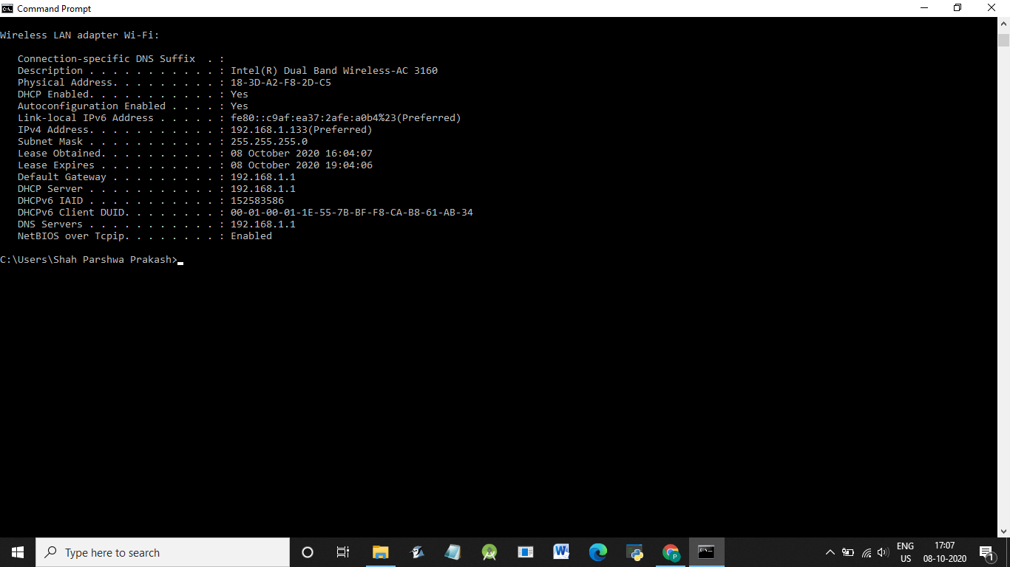

netstat — The netstat command gives information about network connections. I often use netstat -t -n which lists currently open TCP connections (that's the "-t" option) by IP address rather than domain name (that's the "-n" option). Add the option "-l" (lower case ell) to list listening sockets, that is sockets that have been opened by server programs to wait for connection requests from clients: netstat -t -n -l. (On Mac, use netstat -p tcp to list tcp connections, and add "-a" to include listening sockets in the list

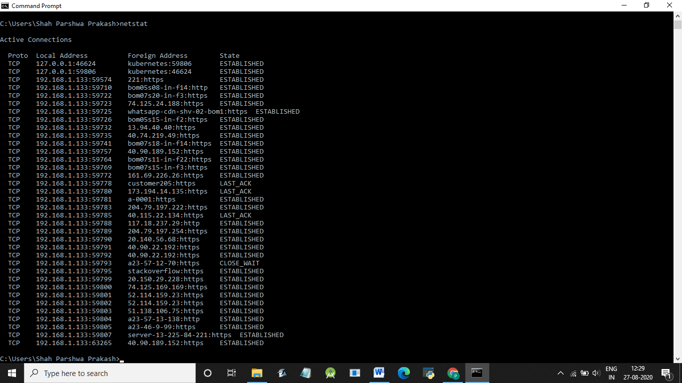

Arp :

Most of the computer programs/applications use logical address (IP address) to send/receive messages, however the actual communication happens over the physical address (MAC address) i.e from layer 2 of OSI model. So our mission is to get the destination MAC address which helps in communicating with other devices. This is where ARP comes into the picture, its functionality is to translate IP address to physical address.
ARP finds the hardware address, also known as Media Access Control (MAC) address, of a host from its known IP address.

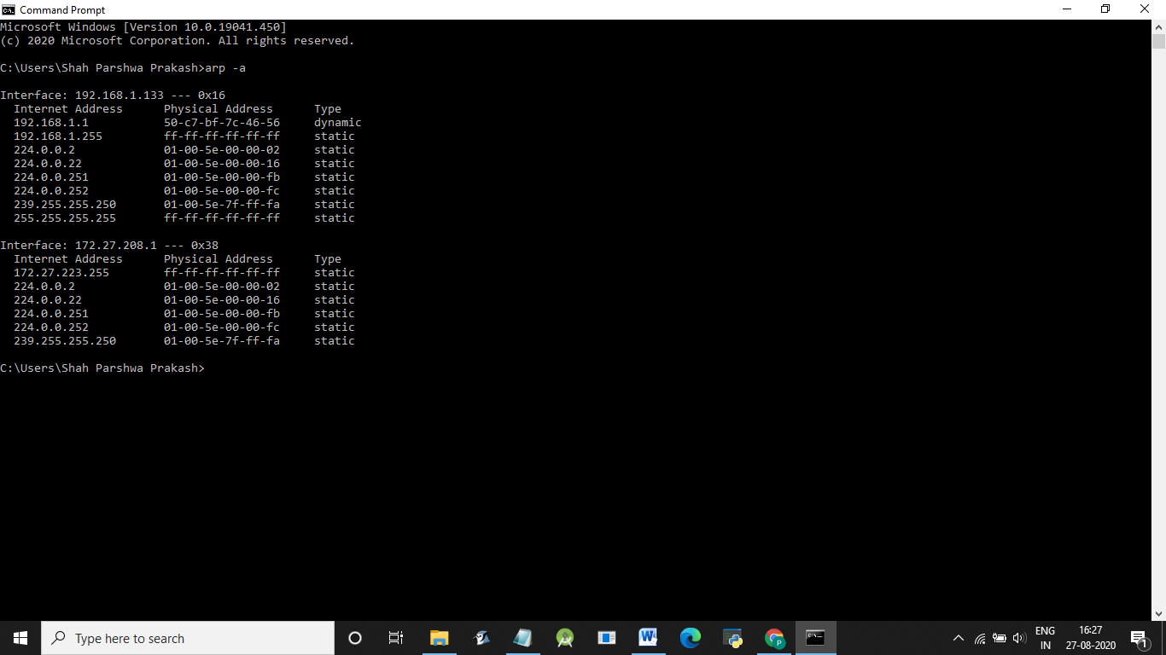
telnet — Telnet is an old program for remote login. It's not used so much for that any more, since it has no security features. But basically, all it does is open a connection to a server and allow server and client to send lines of plain text to each other. It can be used to check that it's possible to connect to a server and, if the server communicates in plain text, even to interact with the server by hand. Since the Web uses a plain text protocol, you can use telnet to connect to a web client and play the part of the web browser. I will suggest that you to do this with your own web server when you write it, but you might want to try it now. When you use telnet in this way, you need to specify both the host and the port number to which you want to connect: telent <host> <port>. For example, to connect to the web server on www.spit.ac.in: telnet spit.ac.in 80

traceroute — Traceroute is discussed in man utility. The command traceroute <host> will show routers encountered by packets on their way from your computer to a specified <host>. For each n = 1, 2, 3,..., traceroute sends a packet with "time-to-live" (ttl) equal to n. Every time a router forwards a packet, it decreases the ttl of the packet by one. If the ttl drops to zero, the router discards the packet and sends an error message back to the sender of the packet. (Again, as with ping, the packets might be blocked or might not even be sent, so that the error messages will never be received.) The sender gets the identity of the router from the source of the error message. Traceroute will send packets until n reaches some set upper bound or until a packet actually gets through to the destination. It actually does this three times for each n. In this way, it identifies routers that are one step, two steps, three steps, ... away from the source computer. A packet for which no response is received is indicated in the output as a *.

Traceroute is installed on the computers. If was not installed in your virtual server last week, but you can install it with the command sudo apt-get install traceroute

The path taken through a network, can be measured using traceroute. The syntax for the command in Linux is:
traceroute <hostname>

The syntax in Windows is:

tracert <hostname>

You can specify either a hostname (e.g., cs.iitb.ac.in) or an IP address (e.g., 128.105.2.6).

1.2.1 Experiments with Traceroute
From your machine traceroute to the following hosts:
- ee.iitb.ac.in
- mscs.mu.edu
- www.cs.grinnell.edu
- csail.mit.edu
- cs.stanford.edu
- cs.manchester.ac.uk
Store the output of each traceroute command in a separate file named traceroute_HOSTNAME.log, replacing HOSTNAME with the hostname for end-host you pinged
(e.g., traceroute_ee.iitb.ac.in.log).
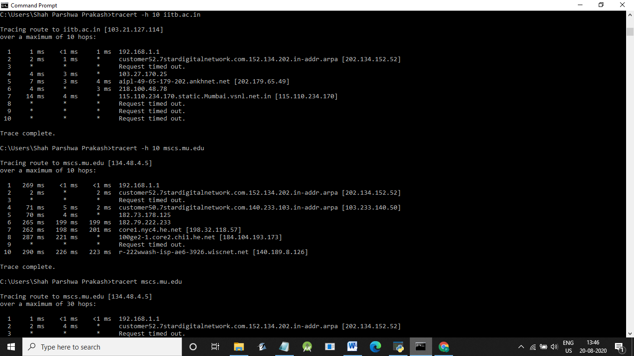

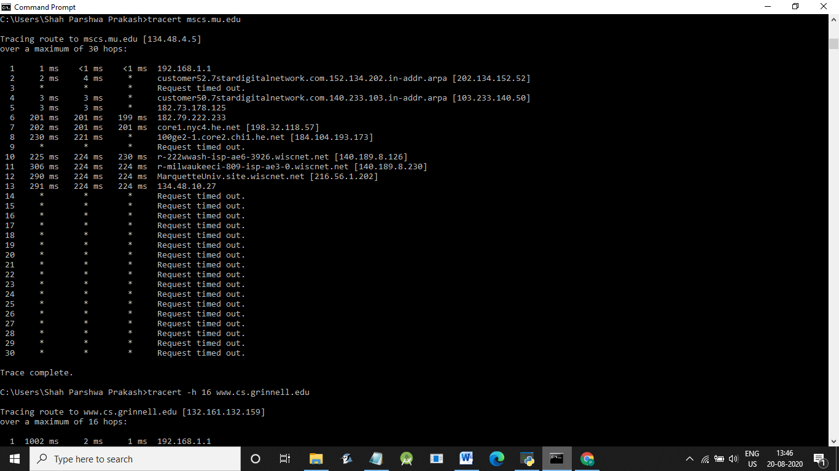

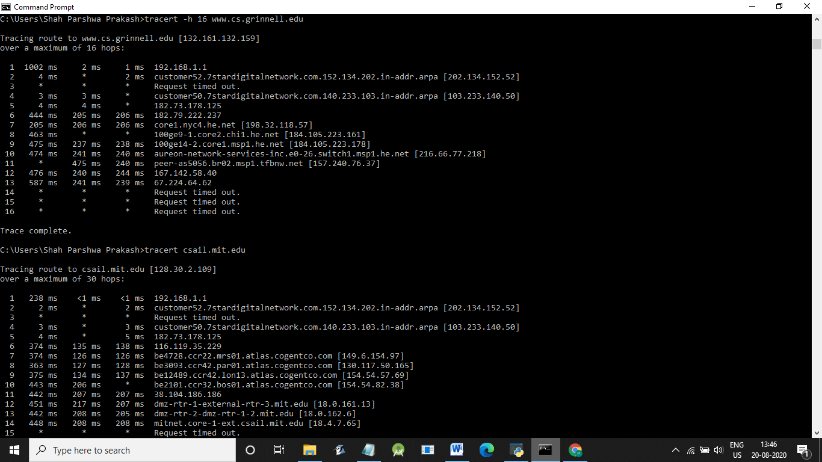

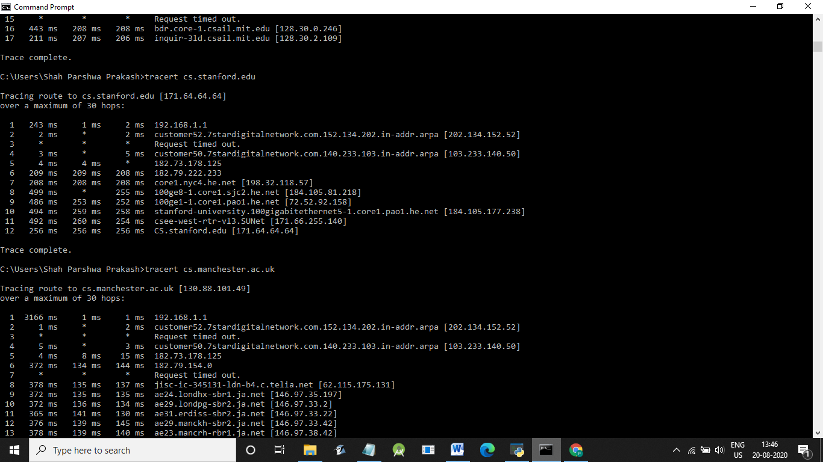

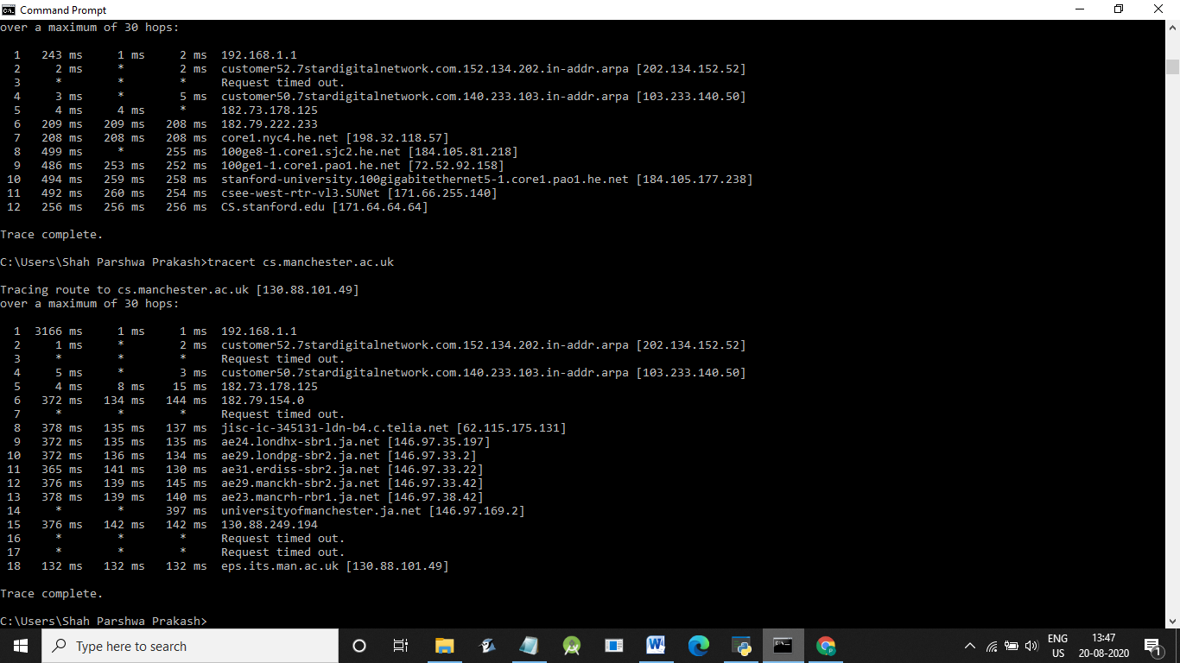

Exercise 2: (Very short.) Use traceroute to trace the route from your computer to math.hws.edu and to www.hws.edu. Explain the difference in the results.

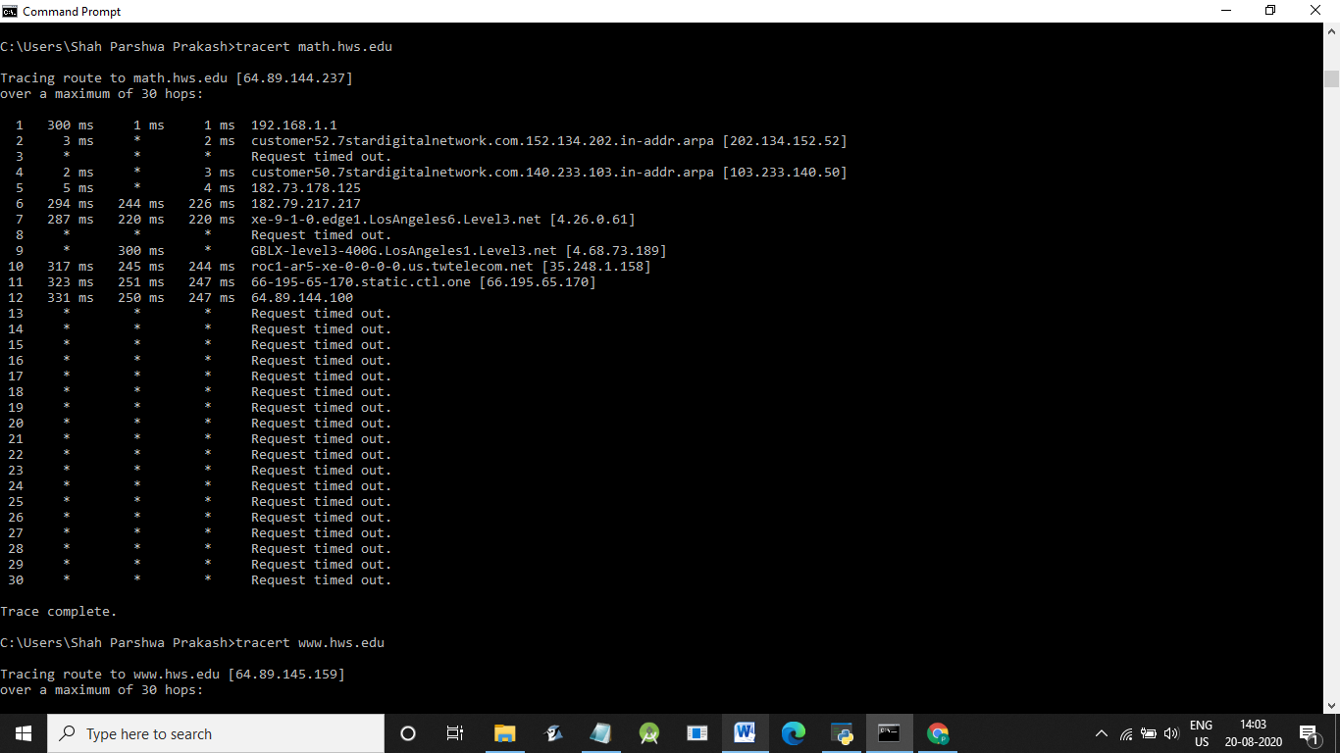

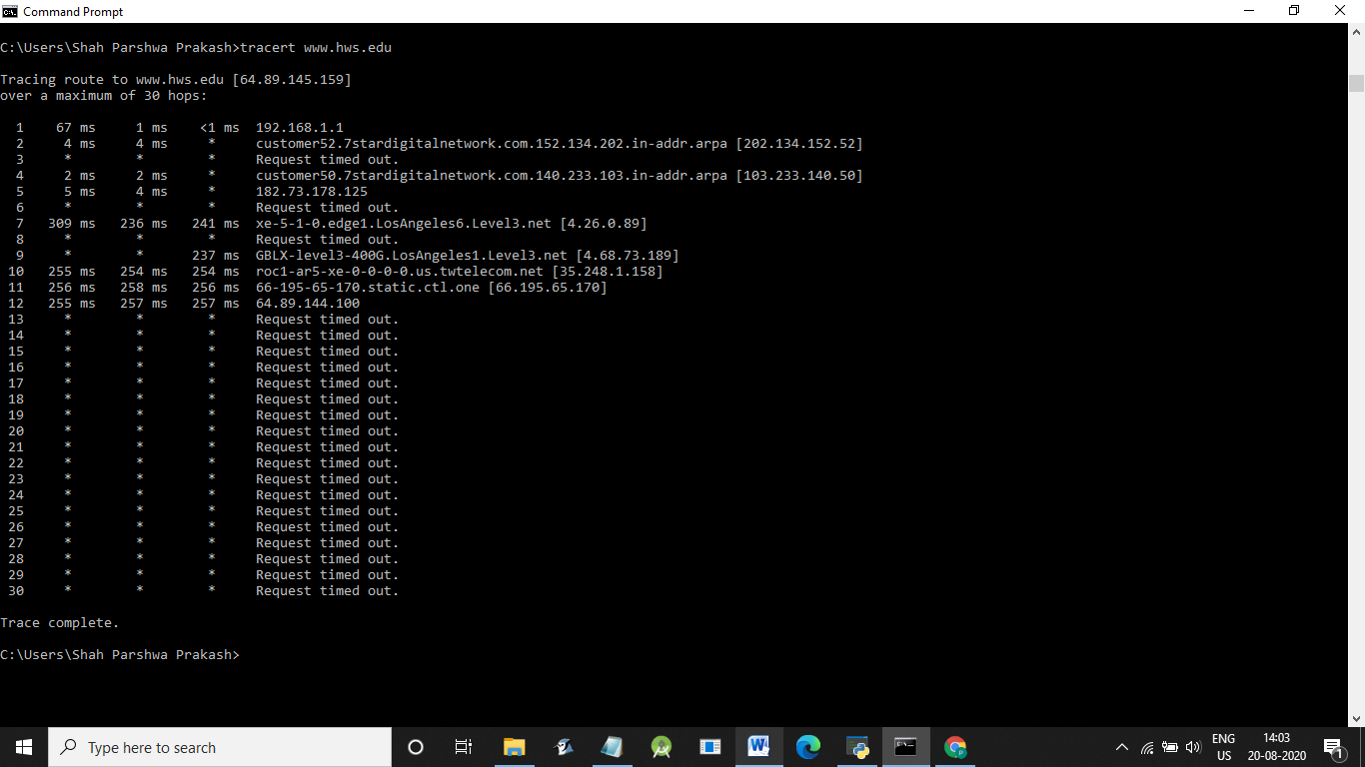

There was a slight difference. I could see change in IP address of both the links. The destination for math.hws.edu was 64.89.144.237 and the one for www.hws.edu was 64.89.145.159.
And, also there was a change in the route.

Exercise 3: Two packets sent from the same source to the same destination do not necessarily follow the same path through the net. Experiment with some sources that are fairly far away. Can you find cases where packets sent to the same destination follow different paths? How likely does it seem to be? What about when the packets are sent at very different times? Save some of the outputs from traceroute. (You can copy them from the Terminal window by highlighting and right-clicking, then paste into a text editor.) Come back sometime next week, try the same destinations again, and compare the results with the results from today. Report your observations.

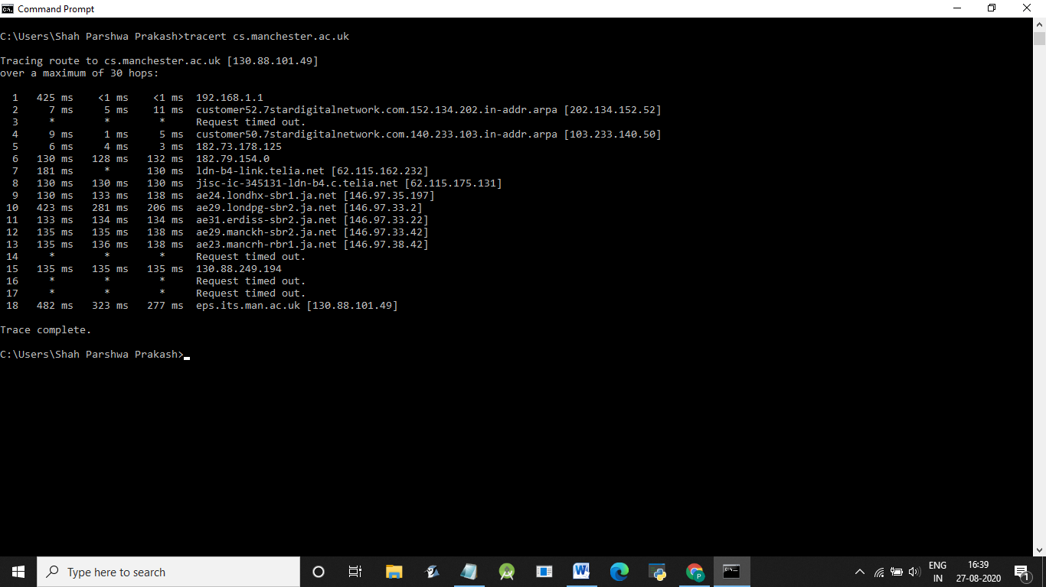

Questions About Paths
Now look at the results you gathered and answer the following questions about the paths taken by your packets. Store your answers in a file named traceroute.txt.
- Is any part of the path common for all hosts you tracerouted?
Yes.Upto 5 hops from my machine its same for all hosts.
- Is there a relationship between the number of nodes that show up in the traceroute and the location of the host? If so, what is this relationship?
There is a proportional relationship.
- Is there a relationship between the number of nodes that show up in the traceroute and latency of the host (from your ping results above)? Does the same relationship hold for all hosts?
The more the number of nodes,the more is the latency for the packer to travel.
Whois — The whois command can give detailed information about domain names and IP addresses. If it is not installed on the computers then install it with command sudo apt-get install whois in. Whois can tell you what organization owns or is responsible for the name or address and where to contact them. It often includes a list of domain name servers for the organization.

When using whois to look up a domain name, use the simple two-part network name, not an individual computer name (for example, whois spit.ac.in).

Exercise 4: (Short.) Use whois to investigate a well-known web site such as google.com or amazon.com, and write a couple of sentences about what you find out.

Exercise 5: (Should be short.) Because of NAT, the domain name spit.ac.in has a different IP address outside of SPIT than it does on campus. Using information in this lab and working on a home computer, find the outside IP address for spit.ac.in. Explain how you did it.

Geolocation — A geolocation service tries to tell, approximately, where a given IP address is located physically. They can't be completely accurate—but they probably get at least the country right most of the time.

This geolocation program is not installed on our computers, but you can access one on the command line using the curl command, which can send HTTP requests and display the response. The following command uses curl to contact a public web service that will look up an IP address for you: curl ipinfo.io/<IP-address>. For a specific example:

curl ipinfo.io/129.64.99.200

(As you can see, you get back more than just the location.)
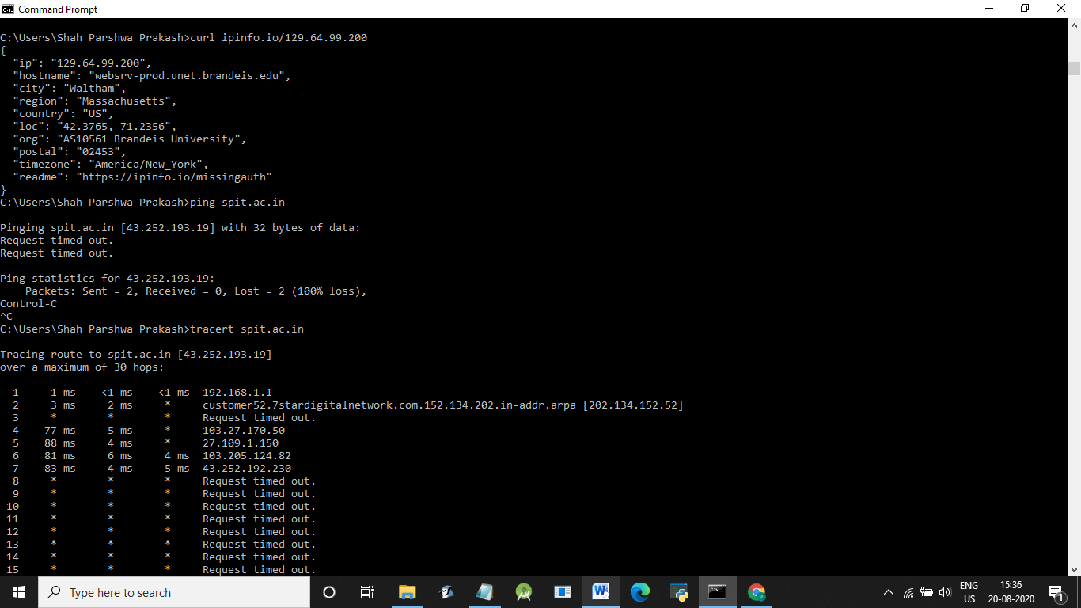

Exercise 6: Find a few IP addresses that are connected to the web server on spit.ac.in right now, and determine where those IP addresses are located. (I'm expecting that there will be several; if not, try again in a few minutes or sometime later.) Find one that is far from Geneva, NY. Explain how you did it.

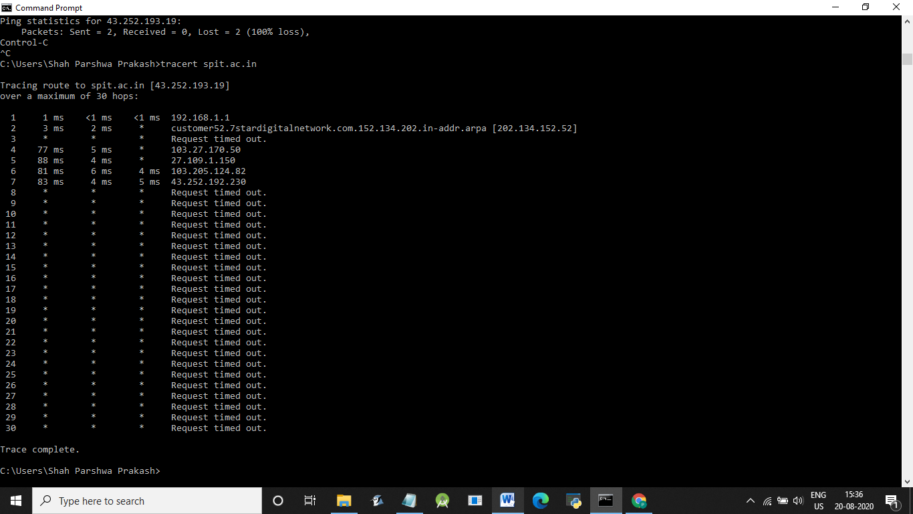
Conclusion:
Hence, from this experiment I implemented various network commands and also got to know the use of each command.

